|  |
| --- |
|  |
| RAK Dash Button User Guide |
| Final |
|  |
| **Ashok Chilukuri** |
| **7/6/2018** |

|  |
| --- |
|  |

Contents

1 Revision History 1

2 Acronyms 1

3 Introduction 2

4 RAK Dash Button Development Environment setup 2

4.1 Hardware Requirement 2

4.2 Software Requirement 2

4.3 Development environment 2

4.3.1 Download the source code 2

4.3.2 Installing driver 2

4.3.3 Set up Arduino IDE 3

4.3.4 The Hardware JTAG connection see below: 6

4.3.5 Run the RDB Device Application code example: 7

5 Device configuration in Web Application 15

# Revision History

|  |  |  |  |
| --- | --- | --- | --- |
| **Version** | **Date** | **Author** | **Remarks** |
| 1.0 | 06/07/2018 | Ashok | Initial release for RDB device |

# Acronyms

RDB – RAK DASH Button device

CREATER pro – CREATER pro device

# Introduction

The document explains the requirement and procedure to setup RAK DASH button to connect to Tantiv4 Server.

# RAK Dash Button Development Environment setup

## Hardware Requirement

1. RAK Dash button
2. System
3. CREATER pro

## Software Requirement

1. Standard ARM MBED CMSIS DAP driver (USB driver for CREATOR pro.)
2. Arduino IDE (From version 1.6.5)
3. Github account

## Development environment

The Dash Button use the CREATOR pro to download the program, so the development environment is same as the CREATOR pro.

### Download the source code

Please download the complete source code package from Github from the following link. The link will be updated after publishing in github

### Installing driver

Step 1: First, Connect CREATOR pro to the computer via Micro USB.

Step 2: If this is the first time you connect CREATOR pro to your computer, you have to install the USB driver for CREATOR pro. CREATOR pro uses the standard ARM MBED CMSIS DAP driver, you can get the installation file and related information in the following website:

<https://developer.mbed.org/handbook/Windows-serial-configuration>

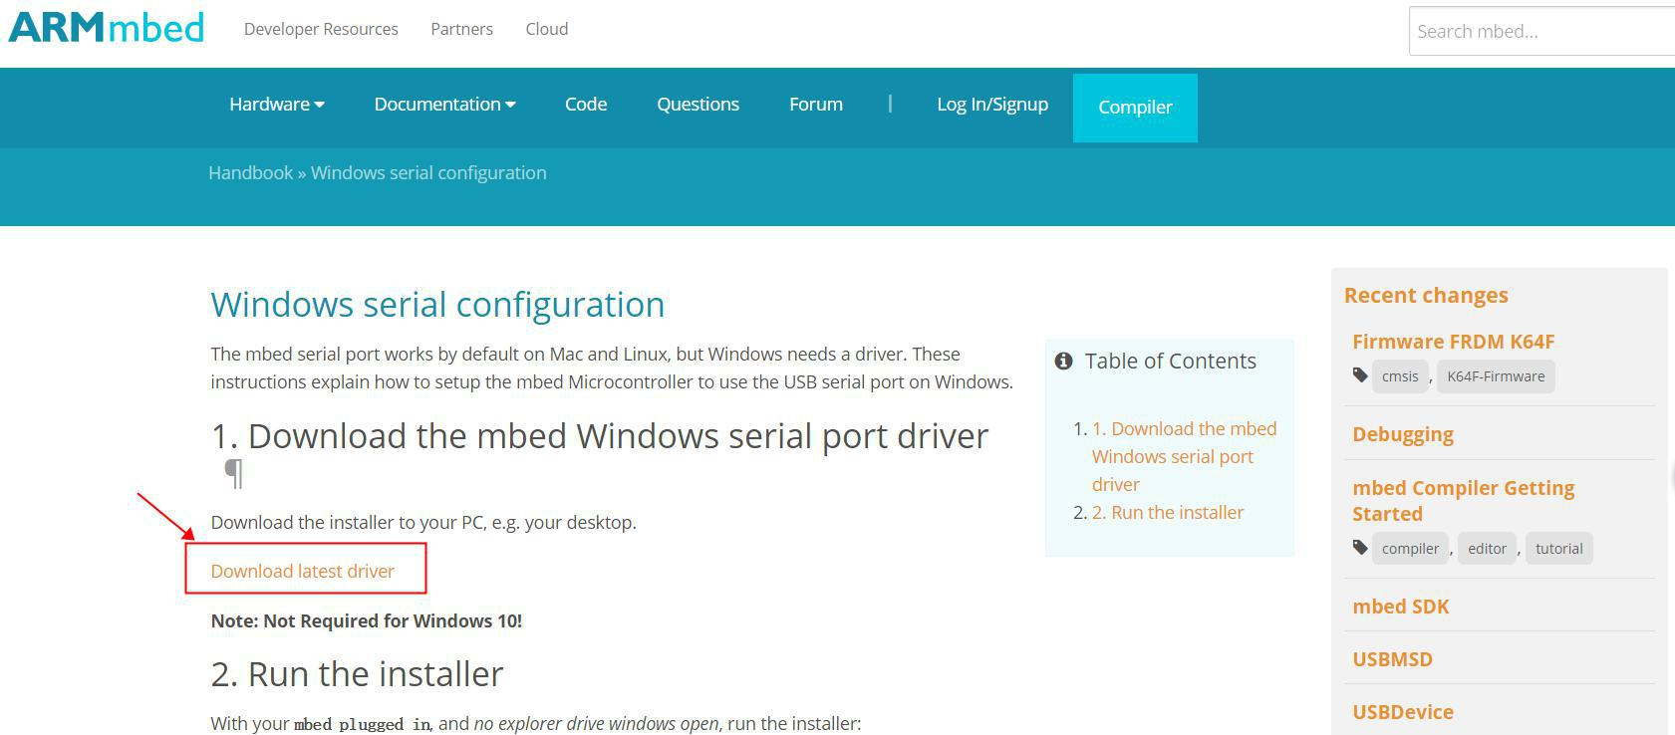

Step 3: In "Download latest driver" download and install MbedWinSerial_16466.exe.

Step 4: If you are using the WIN10 system, when installing the mbed Serial Port driver, the installation fails. Please re-power the module and install the mbed Serial Port driver again. If the device driver does not display the mbed Serial Port driver after installing the driver, update the module DAP firmware.

### Set up Arduino IDE

Step 1) From version 1.6.5, Arduino IDE supports third-party hardware. Therefore, we can use Arduino IDE to develop applications on CREATOR pro, and the examples of Arduino can run on CREATOR pro too. Arduino IDE can be downloaded in the Arduino website:

<https://www.arduino.cc/en/Main/Software>

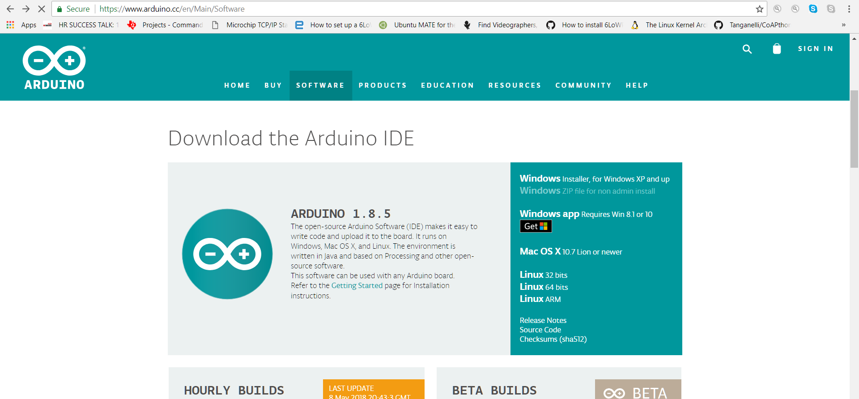

Step 2) When the installation is finished, open up Arduino IDE. To set up **Realtek Ameba** correctly in Arduino IDE, go to "File" -> "Preferences".

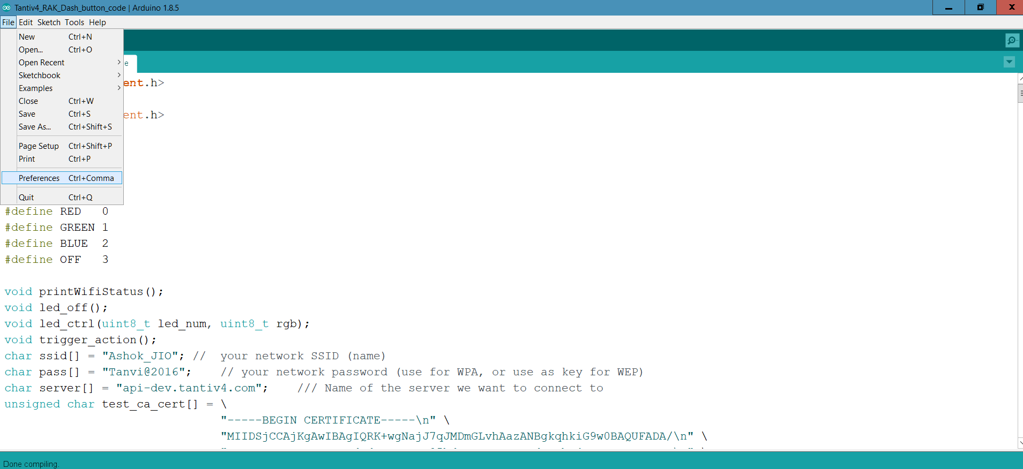

Step 3) And paste the following URL into "Additional Boards Manager URLs" field:

<https://github.com/RAKWireless/CREATOR-Arduino-SDK/raw/master/release/package_rakwireless.com_creator_index.json>

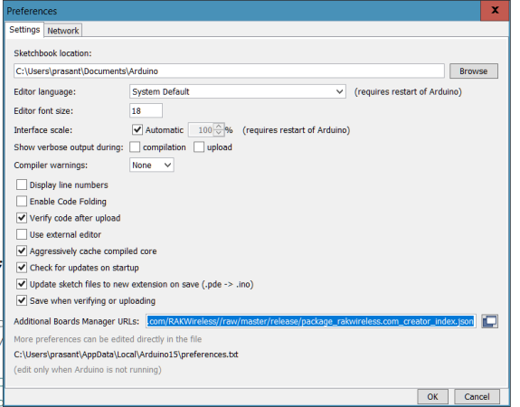

Step 4) Next, go to "Tools" -> "Board" -> "Boards Manager":

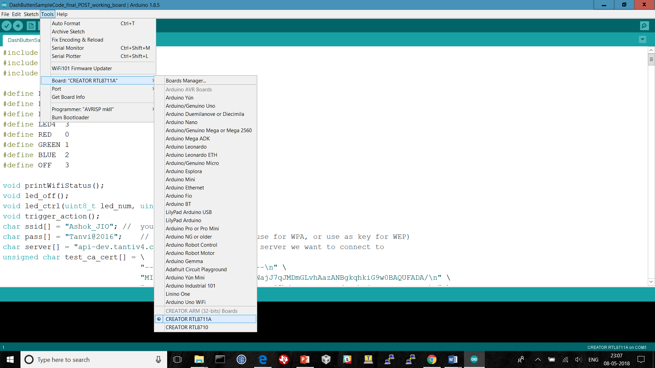

Step 5) The "Boards Manager" requires 10 seconds to refresh all hardware files (if the network is in bad condition, it may take longer). Every time the new hardware is connected, we need to reopen the Board Manager. So, we close the Boards Manager, and then open it again. Find "RAK CREATOR Boards" in the list, click "Install", then the Arduino IDE starts to download required files for CREATOR pro. 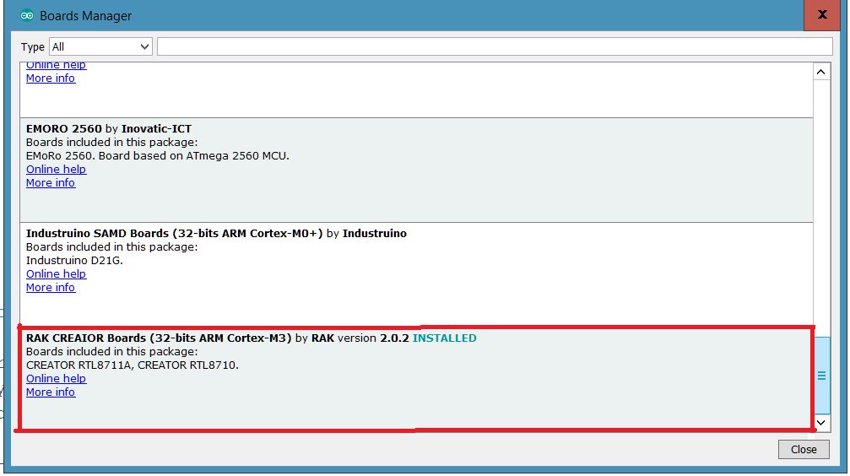

Step 6) Finally, we select CREATOR pro as current connected board in "tools" -> "Board" -> "CREATOR RTL8711A"：（NOTE: RTL8195 and RTL8711 are compatible）

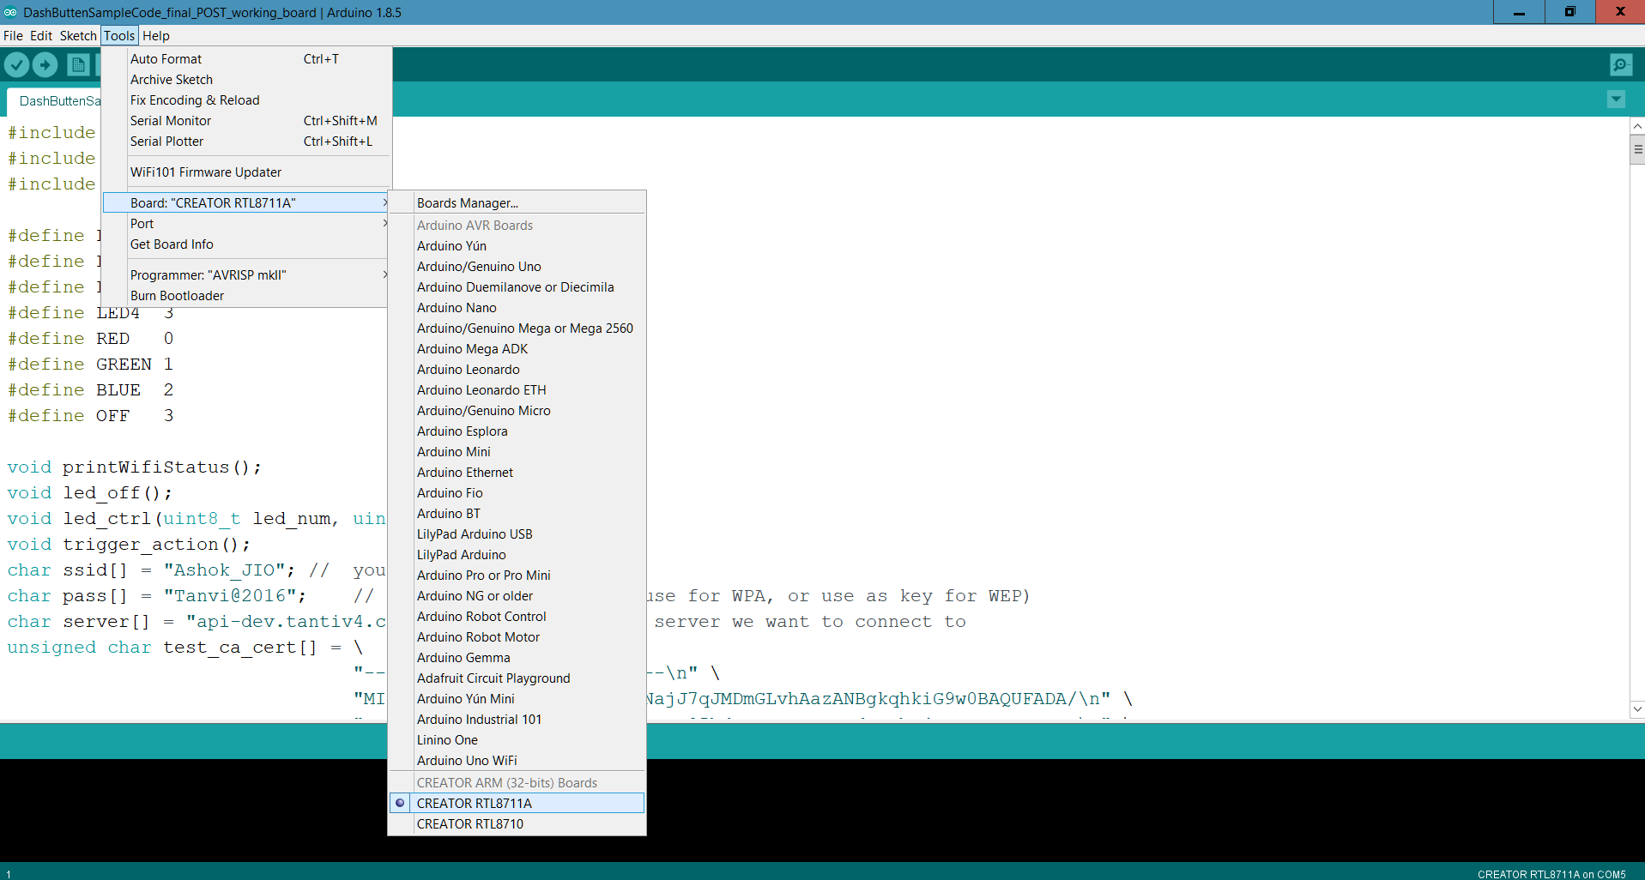

### The Hardware JTAG connection see below

DashButton_V12 version:

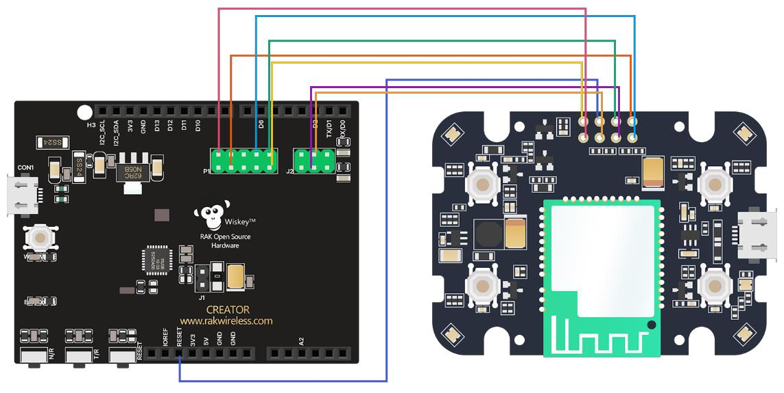

DashButton_V1.1 version:

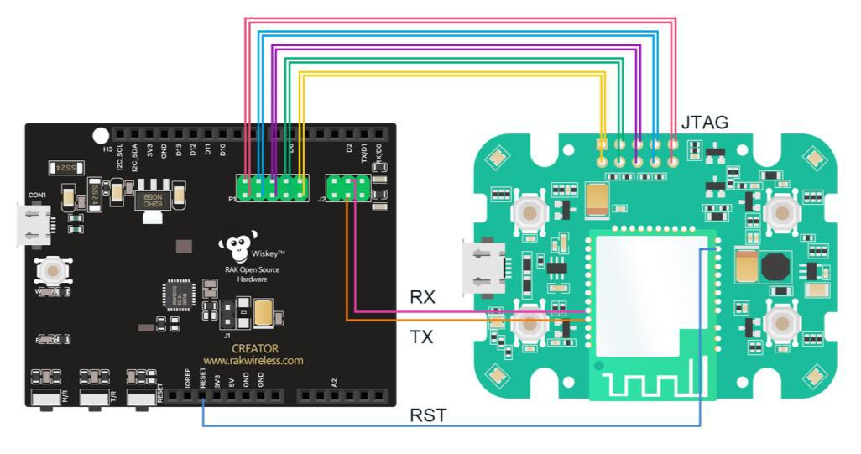

### Run the RDB Device Application code example

Step 1) First, make sure CREATOR pro is selected in Arduino IDE: "Tools" -> "Board" -> "CREATOR RTL8711A"(NOTE:RTL8195 and RTL8711 are compatible).

A screenshot of a computer

Description generated with very high confidence

**Step 2)** Next, Open the **RDB Device Application code** example, "File" -> "Open" -> "<RDB Device Application code file path from **section 4.1**>" and select "RDB_Device_Application_code" file and click on open option.

A screenshot of a computer

Description generated with very high confidence

A screenshot of a social media post

Description generated with very high confidence

**Step 3)** Modify the above source file opened with proper DeviceID and WiFi Access Point details. DeviceID acts as a signature to grant access to Tantiv4 server. WiFi Access Point details like SSID and Password needed to connect RDB to internet.

1. Update Device ID
2. Update WiFi configuration
3. Update Device ID:

Device id is generated in Tantiv4 server. The steps are beyond scope of this document. Please contact us [support@tantiv4.com](mailto:support@tantiv4.com) for to generate device id.

In the place marked below, you can modify the device id for to communicate Tantiv4 server.

A screenshot of a social media post

Description generated with very high confidence

1. Update WiFi configuration:

There are two ways to configure WiFi network,

* 1. Use Predefined WiFi network SSID and PASSWORD
  2. Use WiFi provisioning over HTTP

1. Use Predefined WiFi network SSID and PASSWORD

1. Make sure RE_WIFI_CONFIG_ENABLE set to 0 in code.

#define RE_WIFI_CONFIG_ENABLE 0

In the place marked below, you can modify the device needs to connect the router's SSID and password. We need to reflash/reprogramming device for to change SSID and PASSWORD in device.

A screenshot of a social media post

Description generated with very high confidence

1. Use WiFi provisioning over HTTP
2. Make sure RE_WIFI_CONFIG_ENABLE set to 1 in code.

#define RE_WIFI_CONFIG_ENABLE 1

How to configure WiFi:

1. Connect any Mobile or System to WiFi network with SSID “**RDB**” available. Enter the “**test1234**” as password when prompted.

A screenshot of a social media post

Description generated with very high confidence

A screenshot of a cell phone

Description generated with very high confidence

1. After connection to WiFi network is established, open any web browser and type ”**198.162.1.1:6789**” and enter, a web page as shown in the screenshot.

A screenshot of a cell phone

Description generated with high confidence

1. Enter working Wi-Fi network SSID and password in the box available as shown in the screenshot above.
2. Click on the “Pair” button to send the Wi-Fi network details to device. At this time the web page will be closed.
3. Device will try to connect to given WiFi network and get IP from router. All button LED’s will turn GREEN for half second to indicate device has got IP from router.

Note:

1. Device supports short press only and will send trigger messages to server.
2. There is no LED indication to show device in AP mode or station mode.
3. If Device is in Access Point mode, button press won’t work until access point is configured.

LEDs behavior

1. All LED’s turn Blue for half second - Indicate device is in AP mode.
2. All LED’s turn Green for half second – Indicate device got IP from router.

Step 4) Next, we compile the code directly, click "Sketch" -> "Verify/Compile”, Or you can click the icon in the upper left corner.

A screenshot of a social media post

Description generated with very high confidence

Step 5) Afterwards, we will upload the compiled code to RDB device via CREATOR pro. Please make sure CREATOR pro and RDB device is connected to your system, then click "Sketch" -> "Upload" Or You can also click the shortcut icon.

A screenshot of a cell phone

Description generated with very high confidence

Step 6) Again, during the uploading procedure the IDE prints messages. Uploading procedure requires respectively longer time (depends on system - about 1 minute to 2 minutes). When upload completed, the "upload finish" message is printed.

A screenshot of a cell phone

Description generated with very high confidence

Step7) Finally, Repower the Dash button, and you can see related information shown in serial monitor.A screenshot of a social media post

Description generated with very high confidence

A screenshot of a social media post

Description generated with very high confidence

A screenshot of a social media post

Description generated with very high confidence

Step 8) Device LED behavior to notify device action

Button press:

If any device button is configured and pressed the corresponding LED will turn BLUE until it successfully sends the trigger to Tantiv4 server or timeout. The LED will turn GREEN for one second if it is successful. Otherwise LED will turn RED for one second.

If device buttons are not configured and if any button is pressed, the corresponding LED will turn BLUE until it successfully sends the trigger to Tantiv4 server or timeout. LED will turn RED for one second in both success or failure cases.

WiFi reconfiguration:

If WiFi provisioning is enabled, pressing and holding button “2” for 10 seconds will reset WiFi configuration detail from device flash memory. All button LEDs will turn BLUE for half second to indicate device is in Access Point mode.

Step 9) If you encounter any problem, please contact **support@tantiv4.com**.

# Device configuration in Web Application

**Step 1: Signup**

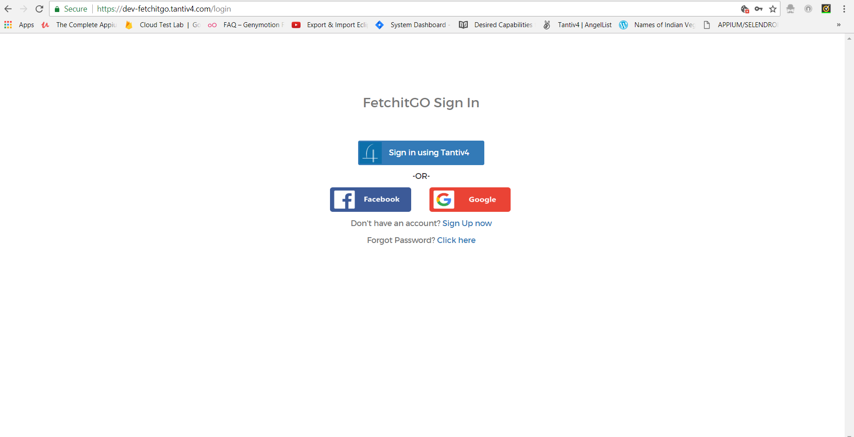

Create your account at **dev-fetchitgo.tantiv4.com** and **Sign Up** through Tantiv4

**Step 2: SignIn**

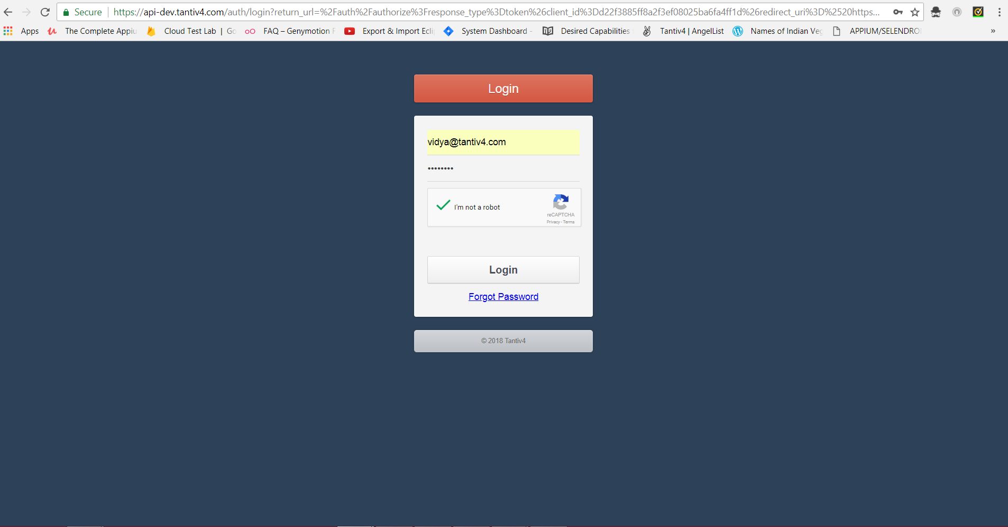

Once you have signed up, go head and login

**Step 3: Add RAK Device**

-> Click on **Beta Link** and click on **RAK** option it will show **Device List page**.

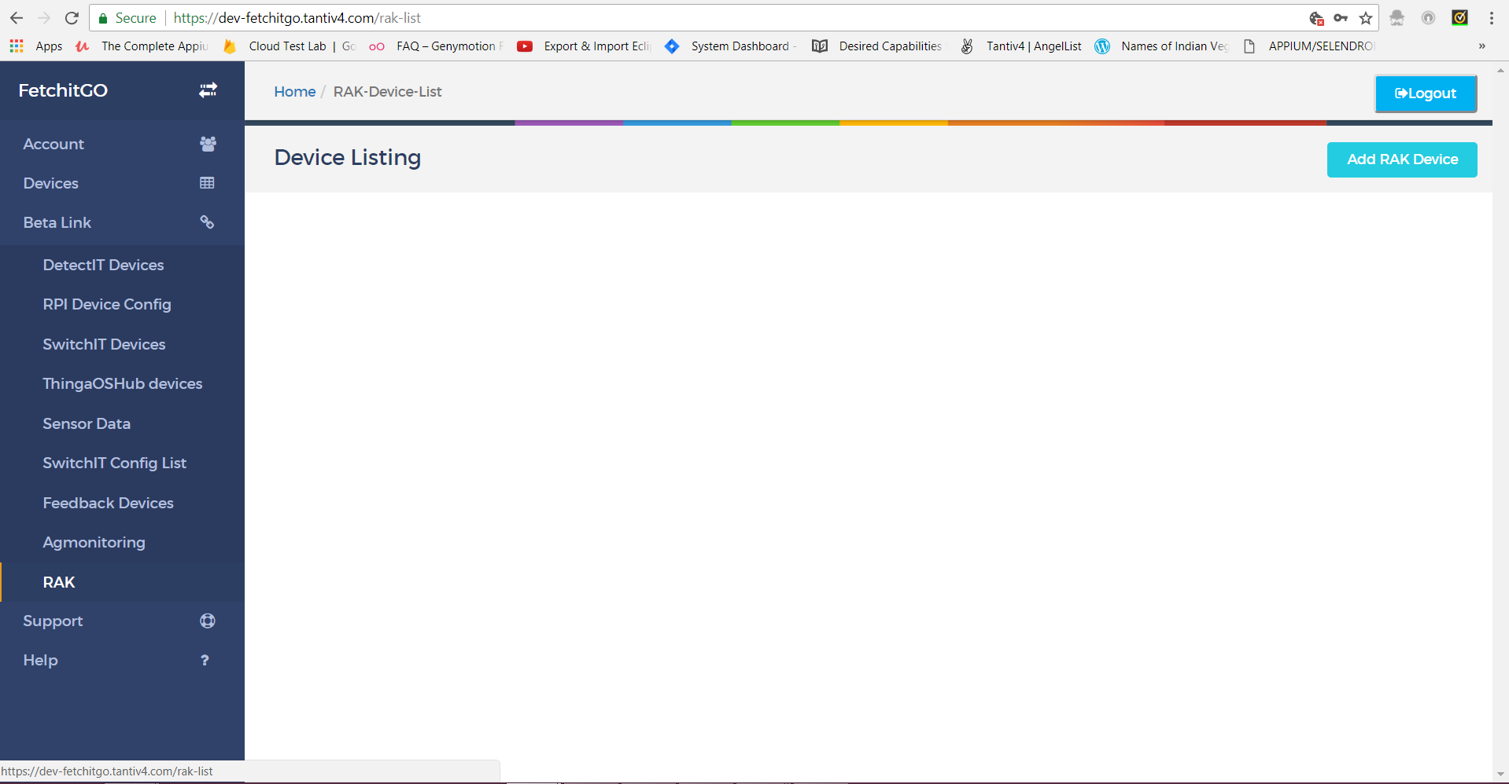

-> In **Devices listing page** by clicking on “**Add RAK Device**” tab you can add device either by entering serial number/customer ID or by Scanning QR code.

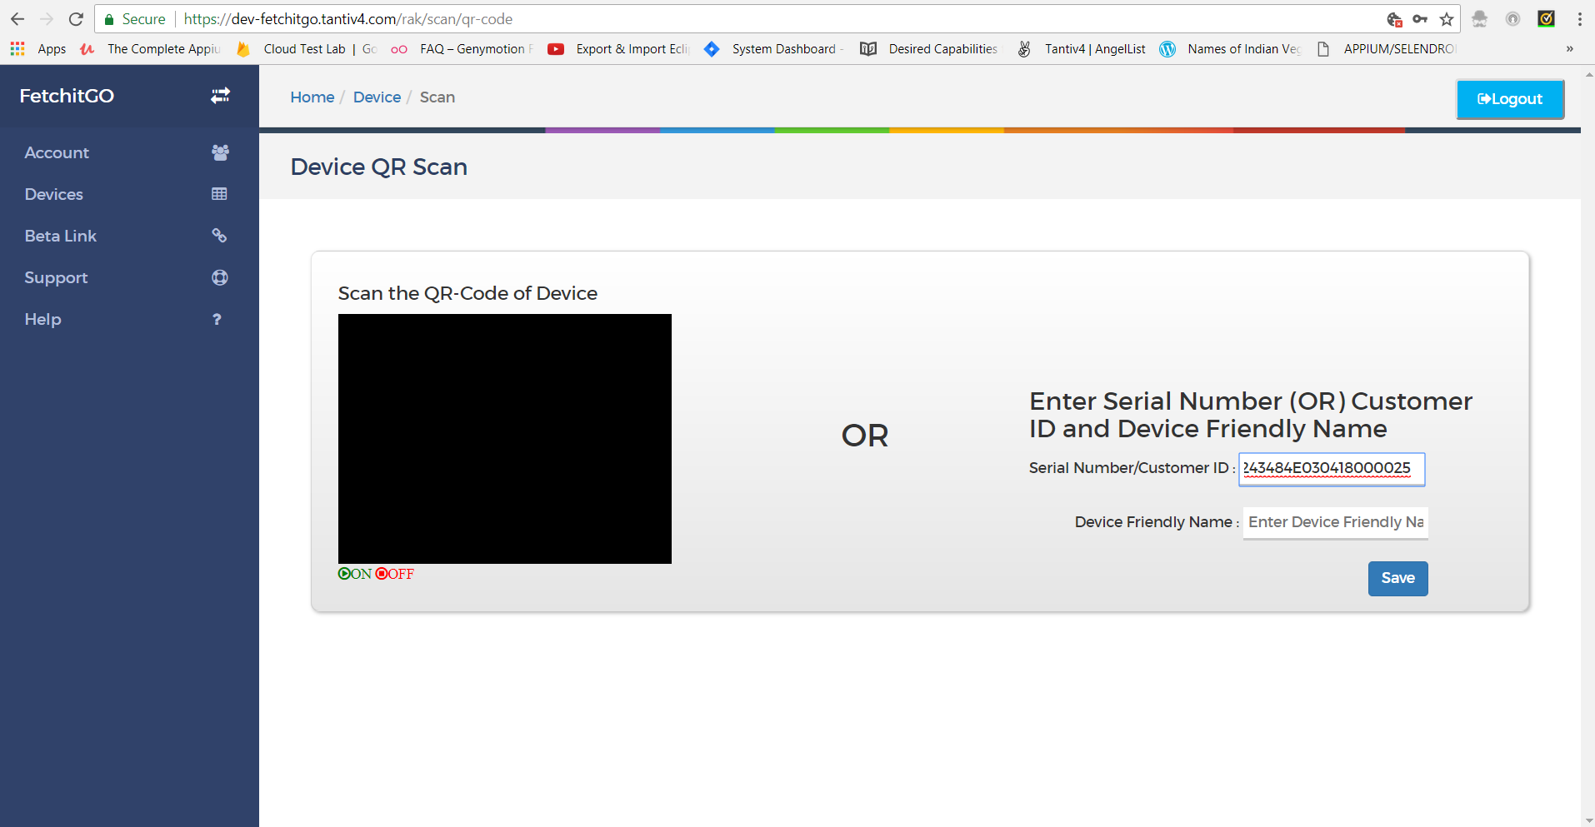

-> Click on **save** button after entered Serial number/customer ID or by Scanning QR code. Device will be added to your account.

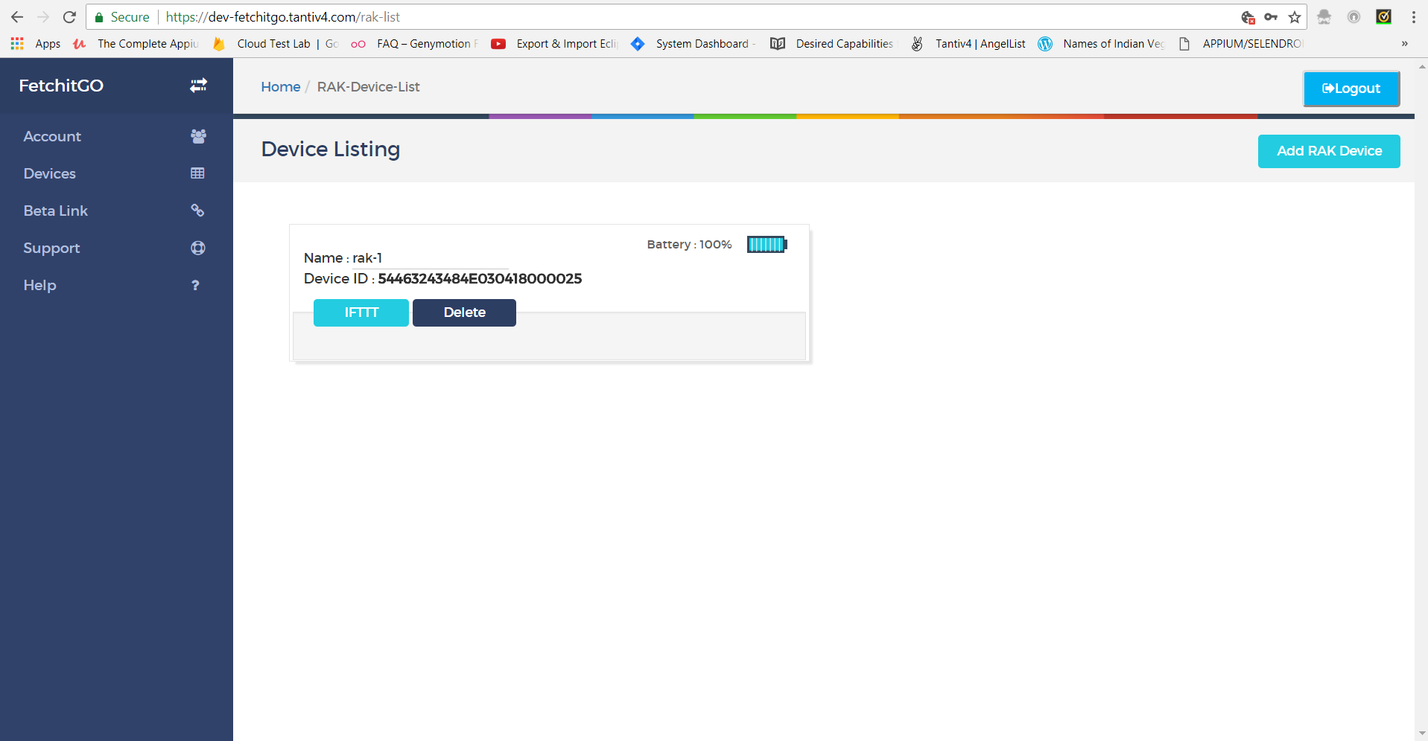

**->** When devices get added successfully device ID and device name is shown.

**Step 4: Device-Configuration**

-> Click on the **IFTTT** option at the bottom of the added device box. You will be directed to the Device-Action viewing page with 4 buttons.

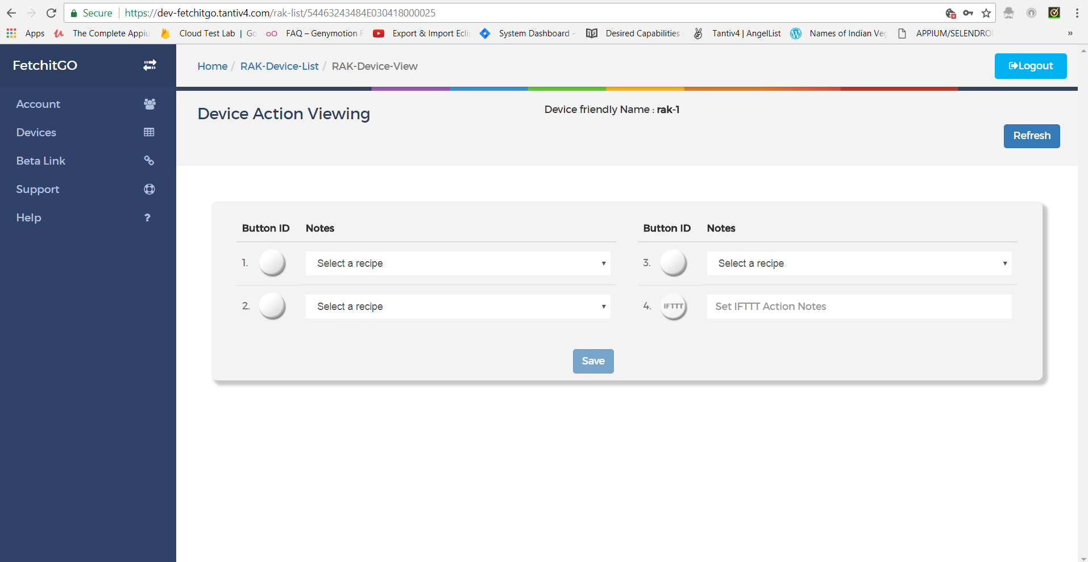

->Click on **button** it will re-direct to **IFTTT page**.

->Create **New Applet** in IFTTT

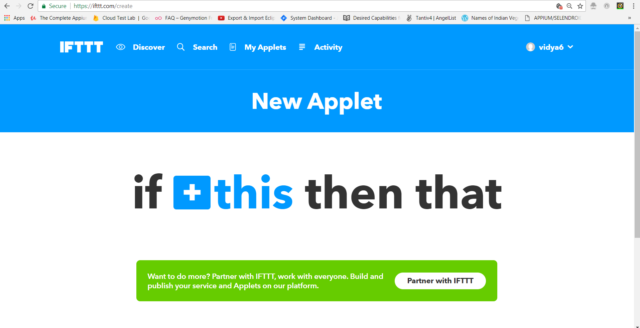

-> Click on **+ this** and choose service as **Thinga (Staging)** it will show **Choose Trigger page.**

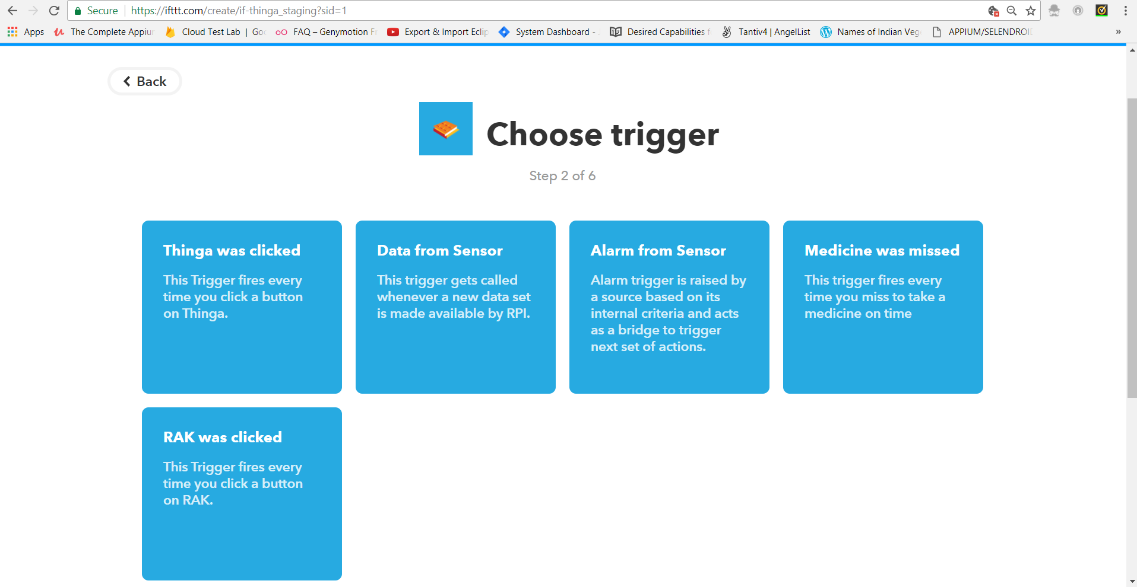

->Click on **RAK was clicked** it will show **Complete Trigger fields page** with device id and button number.

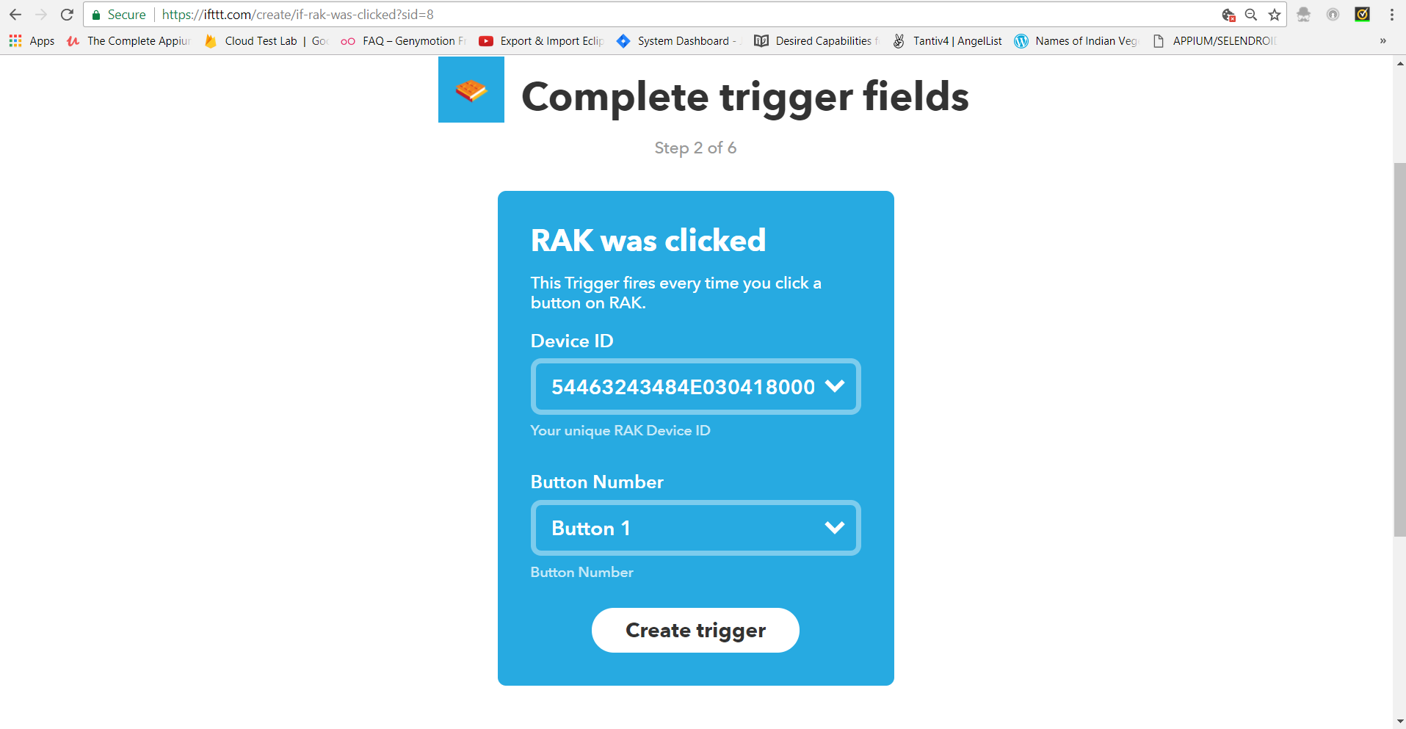

->Configure the device with Device ID, Button number and click on **Create Trigger**.

->Select **+that** it will show **Choose Action Services page** and Select any services like **Gmail**, **Slack** etc.

# References